## **User’s Manual**

Visual Voyagers can be used in two different ways: using a VR headset (specifically the HTC Vive or Oculus Quest 2) or with an emulator. The VR headset is the best way to enjoy the application, however, we recognize that not everybody can afford a VR headset, which is why the emulator version is available. In the end, both versions of the app have the same features. After downloading the respective zip file and unzipping it, Visual Voyagers can be launched by clicking on the Visual Voyagers executable file within the unzipped folder.

When first launching the application, the user will be able to see various controls in the middle of the screen prompting the user to “Log In,” “Create,” and “Join” with the latter two controls pertaining specifically to the multiplayer functionality. “Log In” prompts the user to login to their Google Photos account. After pressing the button, the user will have to take off their headset (if using the VR version) to login through their desktop. Once they’ve completed the process, they will be prompted to return back to Unity, meaning that they can put their headset back on. Once they do so, they can host a room for other players, join someone else’s room, or just enjoy Visual Voyagers by themself.

On the left side of the screen, the user will be able to see a placeholder for the room code along with the instructions that describe the VR controls. The room code is created when the user is trying to host a room and the placeholder is replaced with an actual code after the user presses “Create.” Afterward, the user will be able to give that code out to whoever they want to join them in the app. If the user is trying to join someone else’s room, instead of pressing “Create,” they need to wait for the host to provide them with a room code. Afterward, the user types in the room code in the provided text box and presses “Join.” Immediately after successfully joining the host’s room, the client should be able to see and hear the host and any other clients around them.

### **VR User Manual**

The compatible VR headsets for Visual Voyagers come with two controllers that allow the user to walk around and interact with the environment. Controllers typically come with at least a trackpad in the center and a trigger on the back.

The left controller has a teleportation ray and a circular reticle at the end of it. By moving the controller around, the user can control where they want to teleport, with the reticle demonstrating the exact location they will end up in. The left trackpad allows the user to move around. The left trigger controls the teleportation feature.

The right controller has an interaction ray that points out from the end of it. By moving that controller around, the user can control where they want to point and interact with. The user can only interact with buttons and the keyboard. The right trackpad allows the user to rotate. The right trigger controls the interaction feature.

### **Emulator User Manual**

Instead of using a VR headset and controllers, the user can use an emulator on their PC or laptop. When opening up the emulator version, the following figure appears, describing how the VR controls map out on the keyboard and mouse.

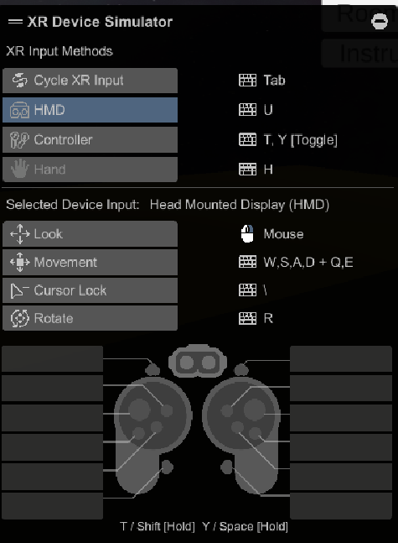

**Figure 7.)** Keyboard and mouse instructions for the XR Device simulator.